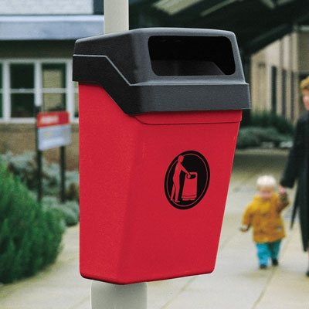£126.56 (exc. VAT) – Glasdon UK

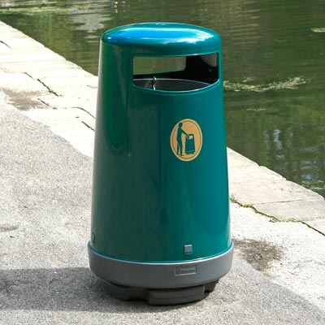

£138 (exc. VAT) (clearance) – Glasdon UK

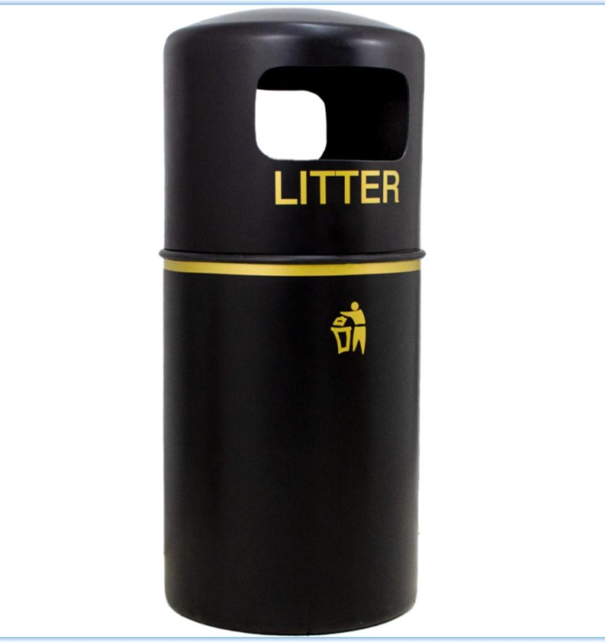

£99.99 (exc. VAT) – Bin Shop

£178.92 (exc. VAT) – Bin Shop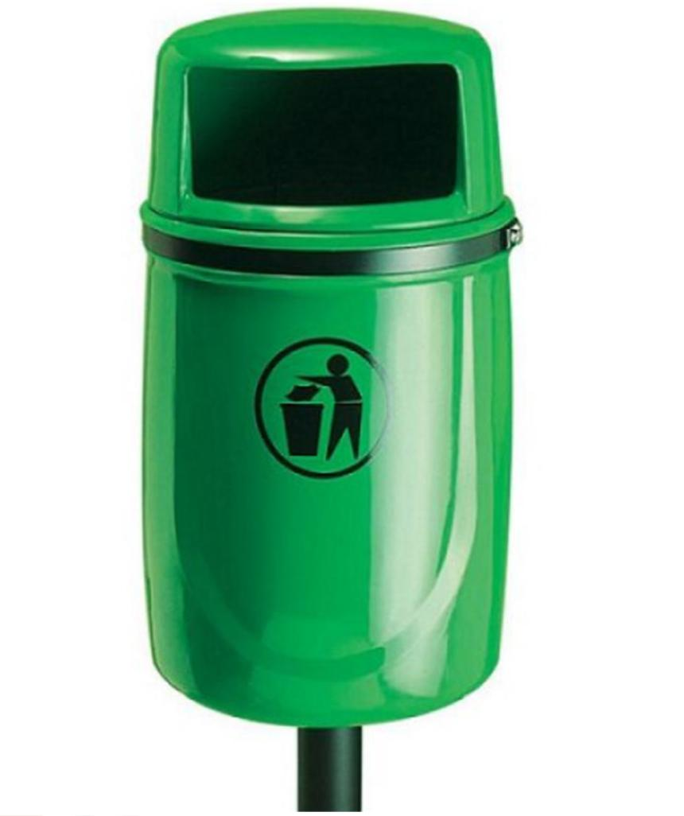

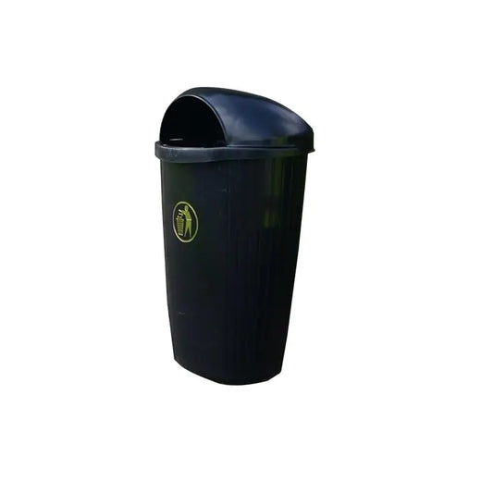

£112.95 (exc. VAT) – Litter Bins

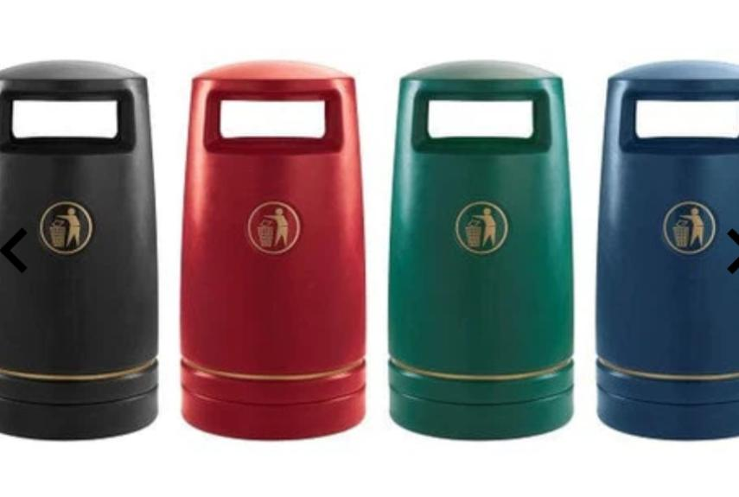

£164.95 (exc. VAT) – Litter Bins