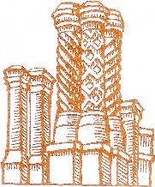
ALBURY PARISH COUNCIL

Serving Farley Green, Brook, Little London & Newlands Corner

Parish Council Complaints Form

Complainant's Details
Name:
Address:
Phone:
Email:

Nature of Complaint
Please describe the nature of your complaint:

Details of Complaint
Please provide details of your complaint:

Supporting Evidence
Please provide any supporting evidence (if applicable):

For Council Use Only
Date Received:
Reference Number:
Action Taken:

Contact Information for Follow-up
For any further questions or follow-up, please contact us at:
Address:
1 Mint Cottages
Park Road
Banstead
Surrey
SM7 3DS
Phone:
07856 010 600
Email:
clerk@alburyparishcouncil.gov.uk

