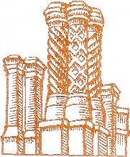
ALBURY PARISH COUNCIL

Serving Farley Green, Brook, Little London & Newlands Corner

Parish Council Decision on Complaint

Complainant's Details
Name:
Address:
Phone:
Email:

Complaint Summary
Summary of the complaint:

Decision
Decision on the complaint:

Reasoning
Reasoning behind the decision:

Actions Taken
Actions taken in response to the complaint:

Contact Information for Follow-up
For any further questions or follow-up, please contact us at:
Address:
1 Mint Cottages
Park Road
Banstead
Surrey
SM7 3DS
Phone:
07856 010 600
Email:
clerk@alburyparishcouncil.gov.uk

